# 用英语讲中国寓言故事——《亡羊补牢》

# Mending the Sheepfold After Losing Sheep

**Once upon a time, there was a man who raised a flock of sheep.One morning, when he went to tend the sheep, he noticed that one sheep was missing.After careful inspection, he found that there was a hole in the sheepfold. It turned out that a wolf had come during the night, dug a hole in the fold, and carried off a sheep. His neighbor advised him, "You'd better repair the sheepfold quickly and block up that hole. Otherwise, the wolf might come again and take more sheep."But the man waved his hand and said, "The sheep has already been lost. What's the use of mending the sheepfold now?" So, he didn't take his neighbor's advice.**

**The next day, when he went to check on the sheep again, he found that another sheep was missing.The wolf had come through the hole once more and taken another sheep.The man was filled with regret. He thought to himself, "If I had listened to my neighbor and mended the sheepfold yesterday, this wouldn't have happened." Without hesitation, he immediately fetched some tools and materials.He repaired the broken part of the sheepfold carefully, making it strong and secure. From then on, the wolf never managed to get into the sheepfold again, and the man didn't lose any more sheep.**

**This story tells us that it's never too late to correct a mistake.Even if we've suffered losses, taking timely remedial measures can prevent further harm.**

**从前，有个人养了一群羊。一天早上，他去放羊时发现少了一只羊。仔细查看后，他发现羊圈上有个洞。原来是夜里来了一只狼，在羊圈上挖了个洞，叼走了一只羊。他的邻居劝他说：“你最好赶紧把羊圈修好，把那个洞堵上。不然，狼可能还会来，叼走更多的羊。”**

**但这人却摆摆手说：“羊都已经丢了，现在修羊圈还有什么用呢？”所以，他没有听从邻居的建议。**

**第二天，他再去查看羊群时，发现又少了一只羊。狼又从那个洞钻进来，叼走了一只羊。**

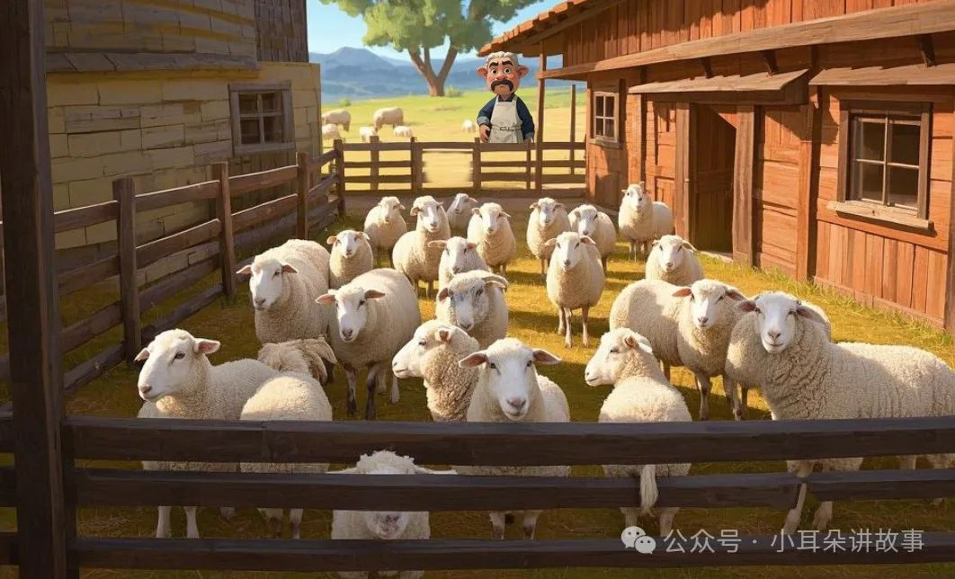

**这人后悔极了。他心想：“要是昨天听了邻居的话，把羊圈修好，就不会发生这种事了。”他毫不犹豫，立刻找来一些工具和材料。他仔细地修补好了羊圈破损的地方，把羊圈修得既牢固又安全。从那以后，狼再也没能钻进羊圈，这个人也没有再丢羊。这个故事告诉我们，犯错后改正永远都不晚。**

**即使我们已经遭受了损失，及时采取补救措施也能避免进一步的损失。**